MORNING WORSHIP SERVICE
Sept 4, 2016

Opening “I Shall Not Be Moved”

Opening Prayer/Announcements
K s b c

Keeping His Word through Sunday School, Bible Study and Church Attendance/Worship

Sunday School Bible Studies for September:

Sept 4th One Great Creator Ps 33:6-9,13-15; Col. 1:15-17
Sept 11th One Great Purpose Isaiah 43:1-7
Sept 18th One Great Problem Romans 3:9-12,19-20,23
Sept 25th One Great Savior Romans 5:6-11

9:45 a.m. each Sunday – A place for everyone

Worship Hymns “Revive Us again” 469
“Let Others See Jesus In You” 571
“He Is Exalted”
“Alleluia” 223

Offering/Offertory

Special Music Brenda Williams

Message Bro. David Atwood

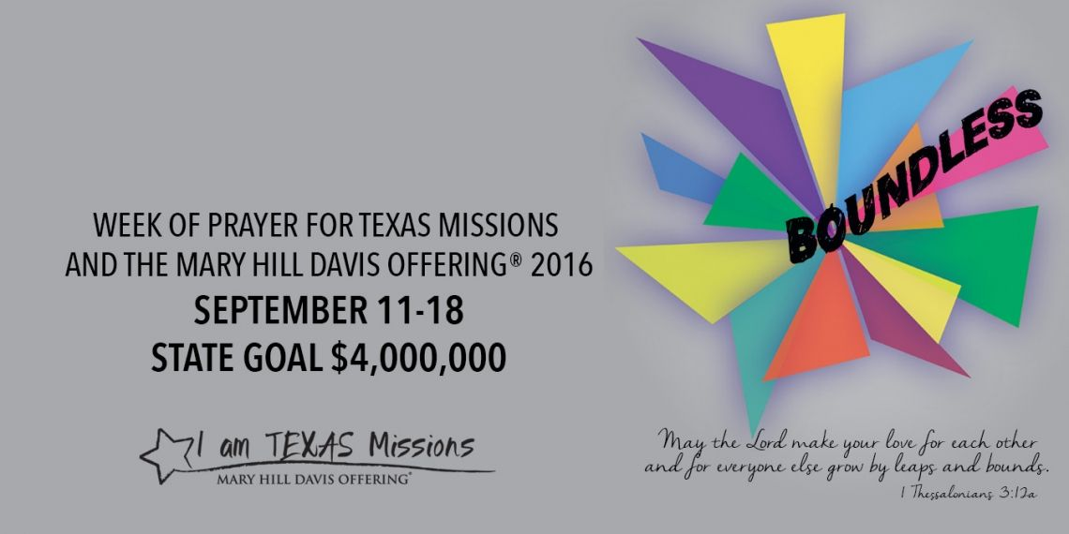

Invitation “I Surrender All” 275

Closing Prayer

Evening Service @ 6:00pm

NURSERY – available for children age 0 to Kindergarten
Otisann McManus, Judy Broussard

Hostesses for September Ushers for September
Brenda Williams, Evelyn Robinson, Jack Radford, Tom Veilleux,
Judy Broussard Joe Wilson, Wayne Marecle

Immediate Need Prayer List
Prayer & Request Information

(Please complete name & address information on reverse side)

❑ I would like to speak with the Pastor.

❑ I would like more information on this church.

❑ I have Prayer Requests or Needs

Date:

Permission to Publicize:
Church Bulletin  Yes  No
Email Prayer Chain  Yes  No

Prayer Request:

Prayer For
Name
Address
Phone

Given By
Name
Address
Phone
Please Contact By

❑ Card  Phone  Visit

Comments

Pray for unsaid fears and concerns

Pray for Helen Emery as she as she settles into her new home in Livingston

Pray for Karlie Griffith, she will be having surgery Sept. 7th

